Deployment

                EC2 instances details, IP addresses

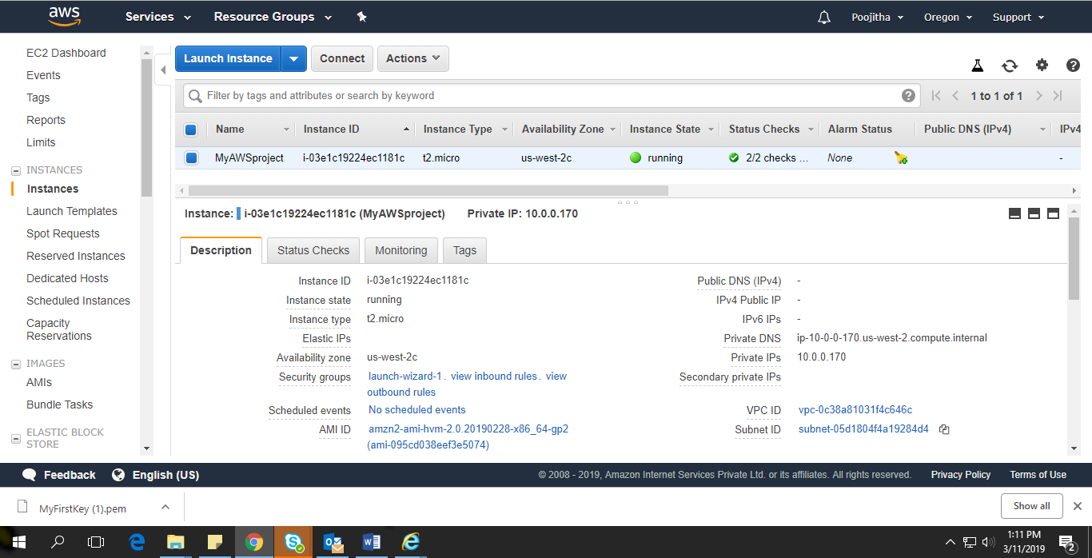

                AMI creation to be used for AutoScaling configuration

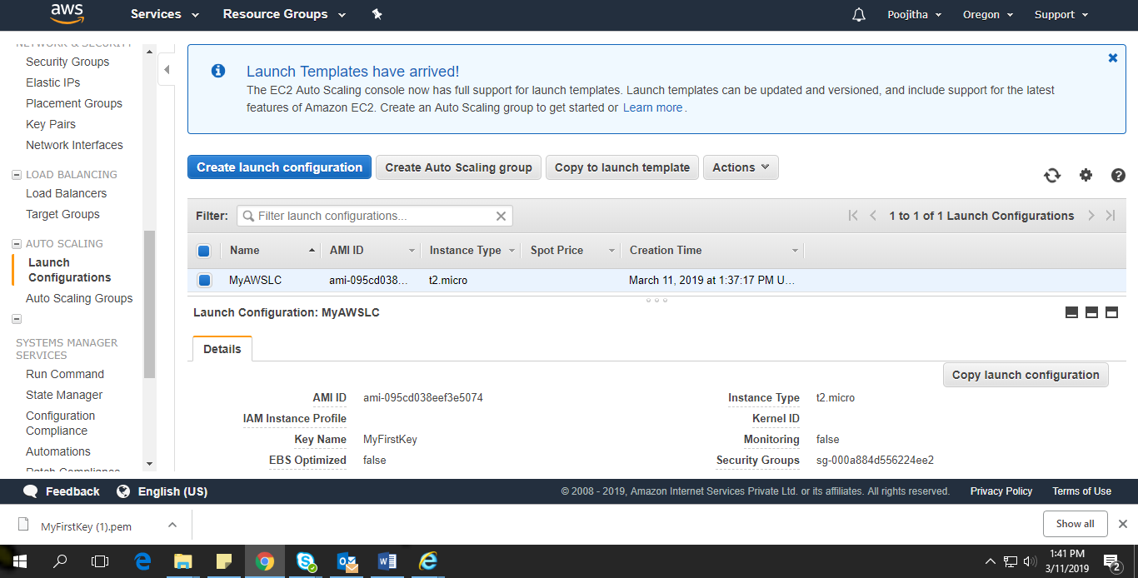

    Autoscaling with minimum, maximum capacity

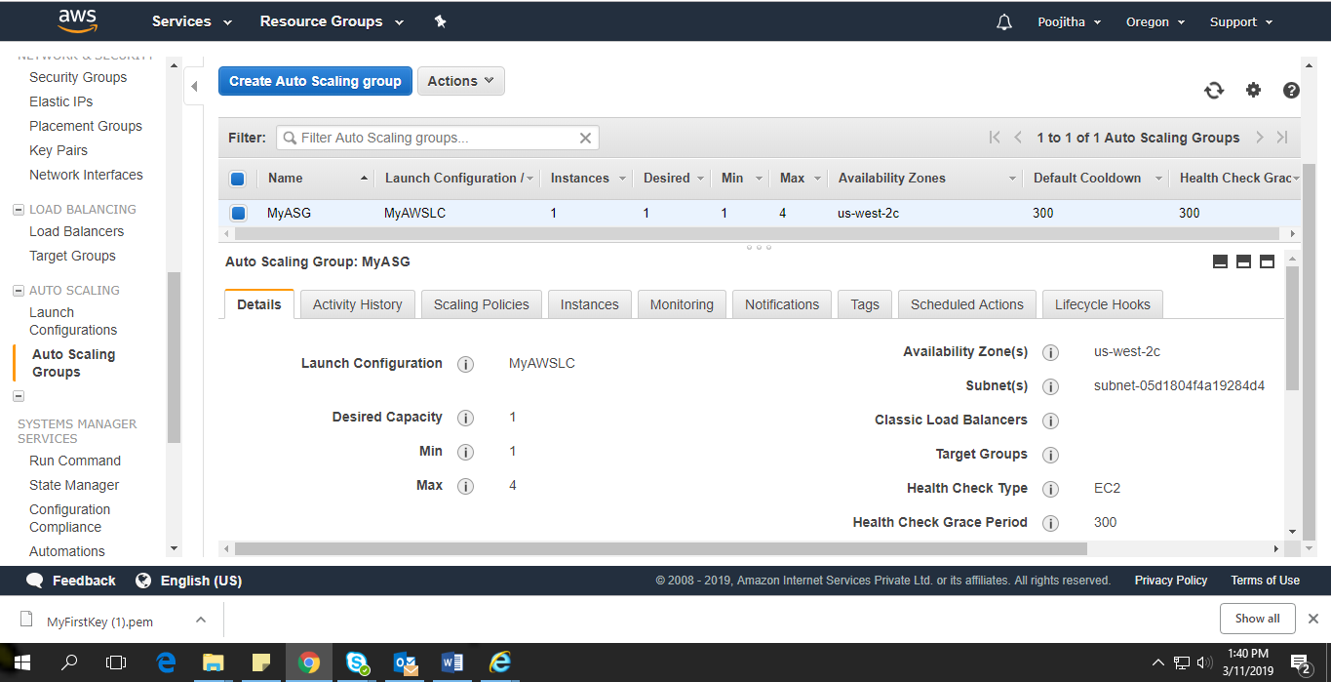

      Load balancing with appropriate health checks

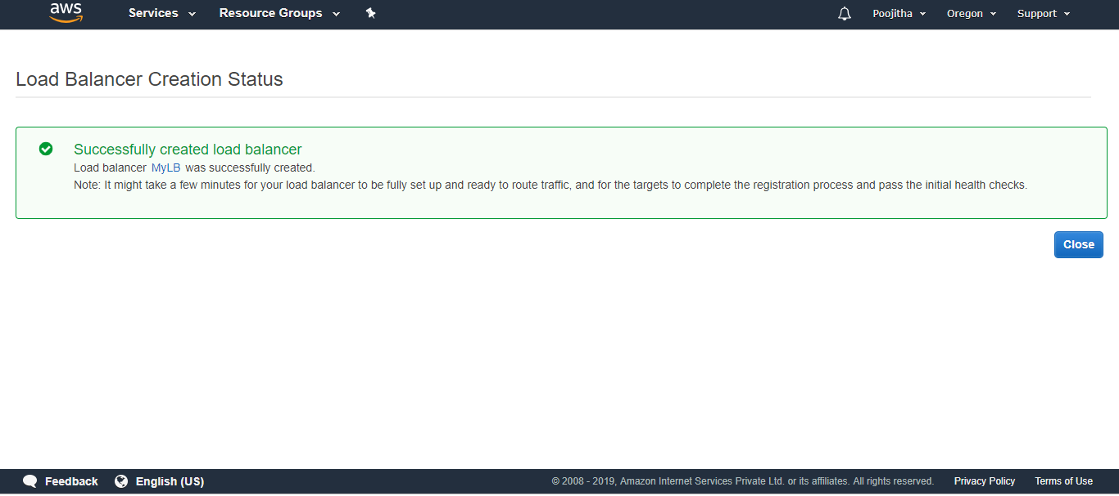

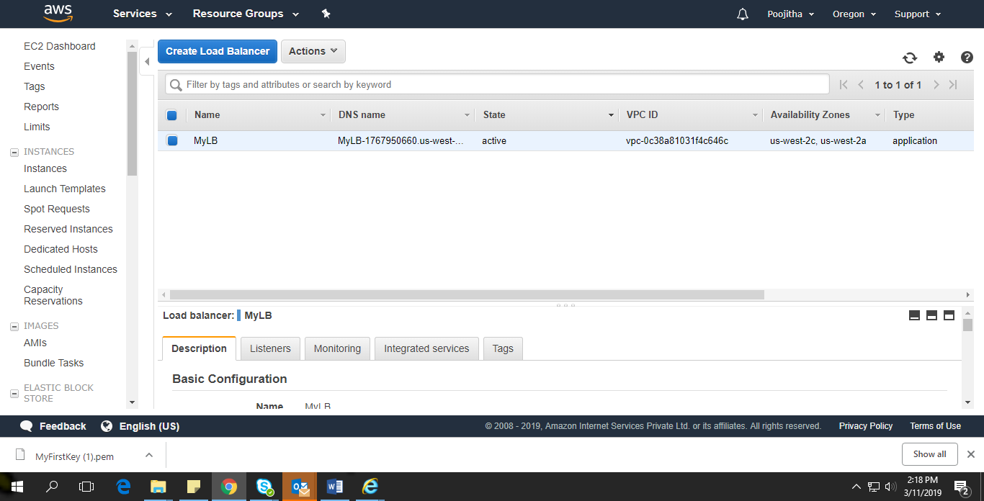

                Cloud watch monitoring with appropriate alarms

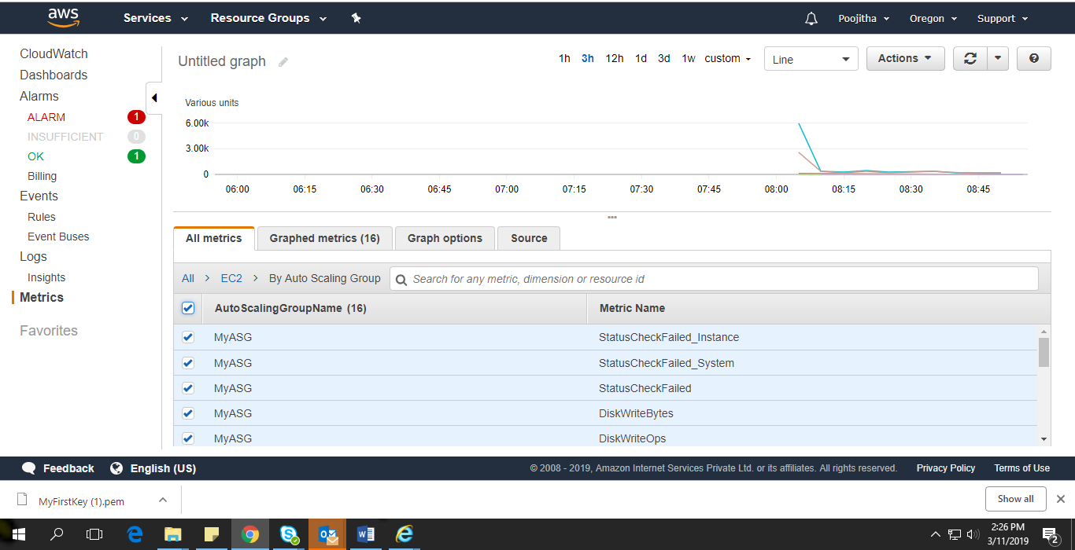

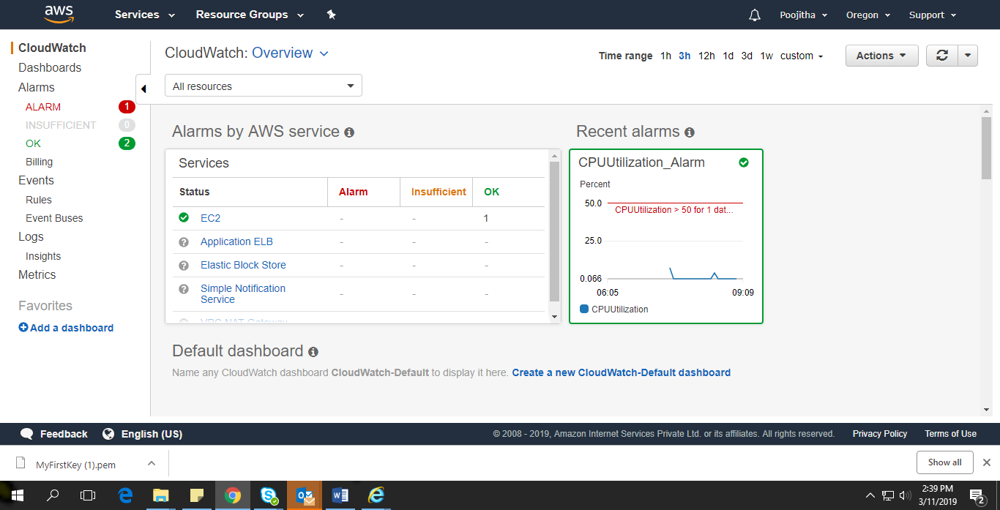

                Logs movement to S3

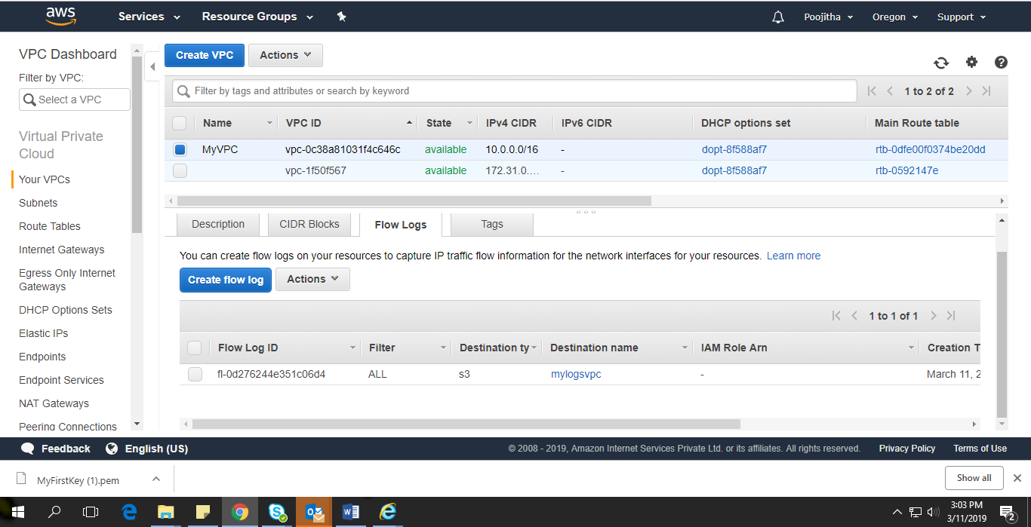

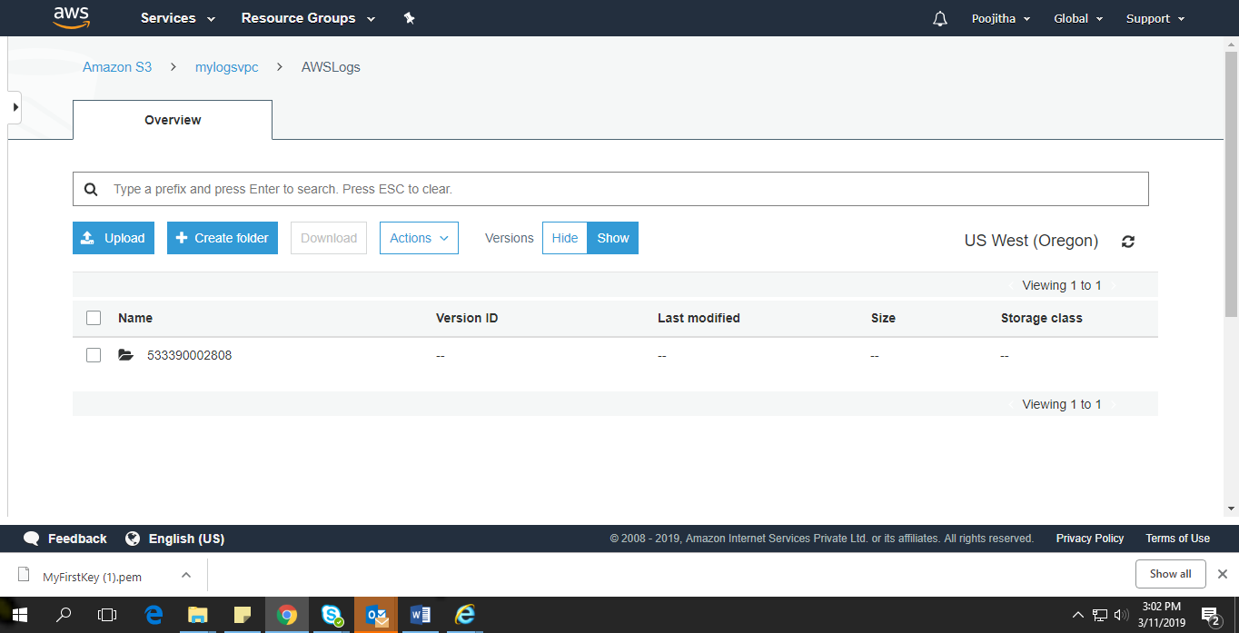

                Appropriate usage of SNS notifications

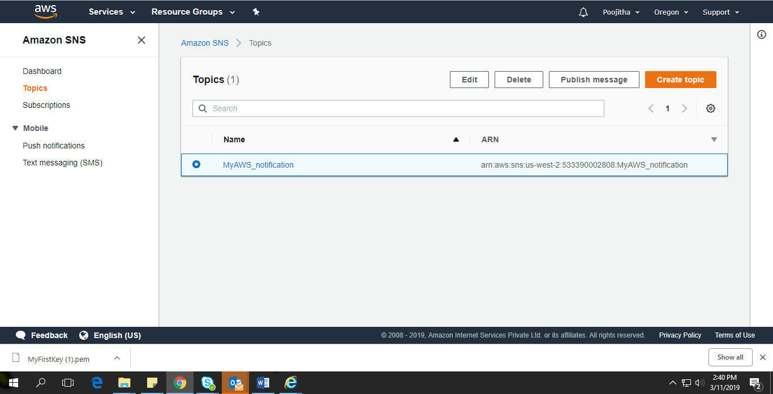

Network layer

                VPC with Public and Private subnet, routers, Internet gateways configuration

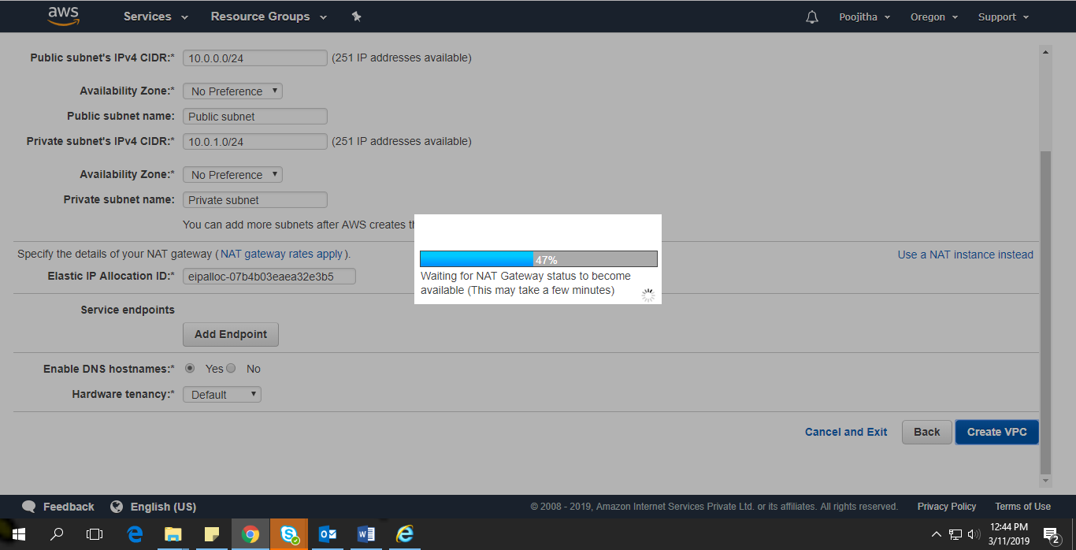

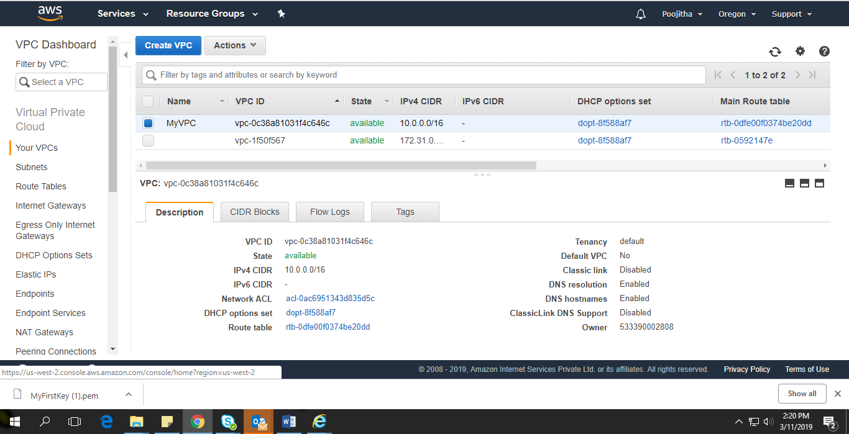

                NAT configuration(NAT Server or Gateway)

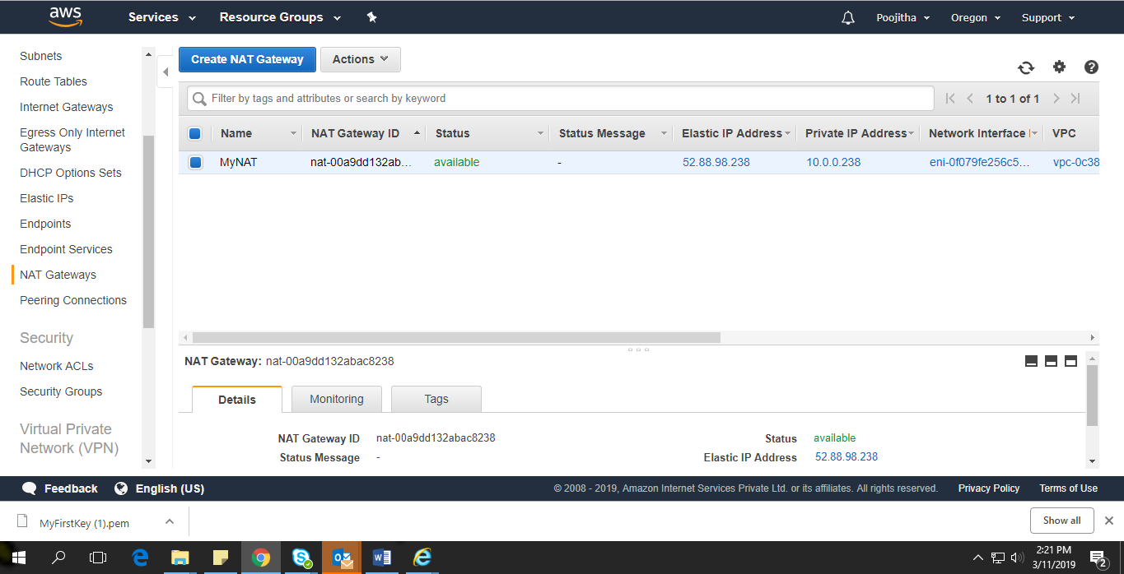

                Appropriate security group creation

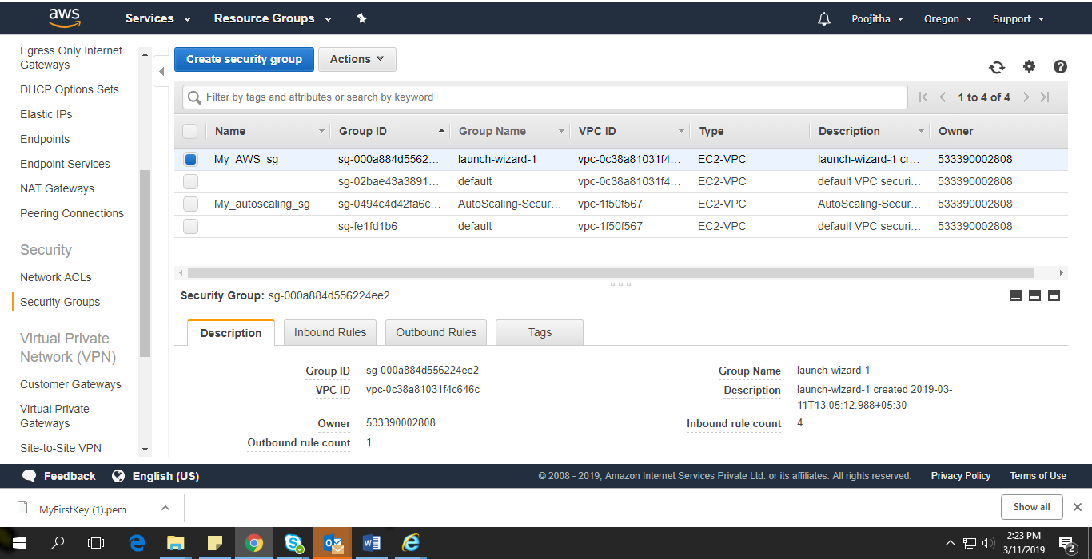

DB Specifications

                Configuration and Security Group rules

                Table and column names as per requirements

Successful connection to database